# Instructions “Seeing while Moving”

## General Information and Setup

Before the experiment starts, please make sure that your Oculus and the Oculus controllers are connected and working. You will do the experiment sitting on a chair. Please also read, fill in and sign the Informed Consent Form.

The experiment consists of four parts and will take about one and a half hours to complete, including setup. The package you downloaded contains one program for each part, for a total of four programs:

1. A First Task: Stereovision Test (2 minutes)
2. A Second Task: Training Session (2-4 minutes)
3. The Third Task: Main Experiment (50 minutes)
4. A Fourth Task: Short Assessment of Self-Motion Perception (2 minutes)

We present the programs in Virtual Reality and you will use your Oculus controllers to interact with the program and give your responses. You can exit every program by pressing the “Esc” button on your keyboard, but in this case, all data are lost. For tasks (2), (3) and (4), it is important that you look at the stimulus frontally: if your Oculus is set up on room scale, please orient your chair towards the scene. If it is set up for seated or standing play, you can re-center the environment by pressing either “X” or “A” on your Oculus controllers at any moment. This centers the scene right in front of you. If you feel motion-sick or dizzy, feel free to take breaks as needed or abort the experiment completely. You will still be compensated proportionally for your time spent. In the following, we explain each task separately.

## First Task: Stereovision Test

**Program:** “Stereotest.exe” in the folder “1_Stereotest”

**Duration:** 2 minutes

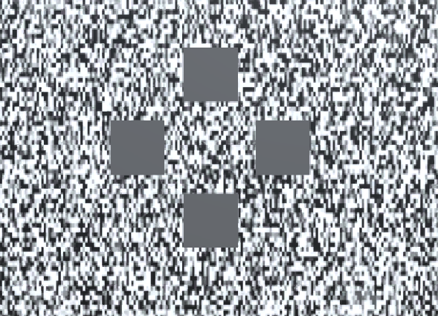

Figure 1: Screenshot from the first task.

In this test, we assess how well you use information coming from both of your eyes simultaneously to perceive depth. We show you four rectangles at a time (**Error! Reference source not found.**). One of them should “pop out” and appear closer to you. The rectangles will always appear right in front of you and move with you as you move your head, but please keep your head as still as possible. You can explore the scene freely with your gaze, no need to fixate anything in particular. Indicate with the joystick of either of your Oculus controllers which of the rectangles pops out and press the trigger to confirm your choice. The task will take about 2 minutes. At the end, the program tells you to either proceed to the next program or to discontinue the experiment. If you are told to continue, please proceed to the training part, described under “Second Task: Training Session”. If you are told to discontinue, please send the datafile back to us. You find the datafile, a .txt file whose name ends in “Stereotest”, in the folder with the executable. We will send you a compensation proportional to your time (5 CAD at this stage) – no need to do the rest of the experiment; we won’t be able to use your data because you haven’t met our criterion for stereovision.

*Disclaimer: In no way does this represent a medical diagnosis, and if you believe you might have problems with your stereovision, please consult a medical provider.*

## Second Task: Training Session

**Program:** “Training.exe” in the folder “2_Training”

**Duration:** 2-4 minutes

|  |  |
| --- | --- |
| Figure 2: Screenshot from training, big target | Figure 3: Screenshot from training, target cloud. |

Now, you will practice the task of the main experiment up to two times. We show you two intervals of motion: one will be one big red ball (Figure 2) and the other will be a cloud of smaller balls (Figure 3). Both are moving in the same direction, either from right to left or left to right. After both motion intervals, please press the trigger of your **left** controller if you think the first motion was faster or press the trigger of your **right** controller if you think the second motion was faster. If you unsure, just make a guess. Please look at the red fixation cross at all times. After about 35 comparisons, this part of the experiment ends. The program tells you to either proceed to the next task or repeat the training. If you are told to continue, please proceed to the main experiment, described under “Third Task: Main Experiment”. Otherwise, please repeat the training. If that time around the program tells you to repeat the task again, please discontinue the experiment and send all data files back to us – no need to proceed with the experiment. You can find the datafile for this experiment, a .txt. file whose name ends in “Training”, in the folder with the program. You will be compensated proportionally to the time spent (10 CAD if you have to drop out at this stage).

## Third Task: Main Experiment

**Program:** “MainExperiment.exe” in the folder “3_MainExperiment”

**Duration:** 40-50 minutes

|  |  |  |  |
| --- | --- | --- | --- |
| Figure 4: Screenshot from main experiment, big target, textured wall. | Figure 5: Screenshot from main experiment, target cloud, textured wall. | Figure 6: Screenshot from main experiment, big target, untextured wall. | Figure 7: Screenshot from main experiment, target cloud, untextured wall. |

This part is very similar to the previous experiment. You will again see two intervals of motion and judge with your Oculus controllers which one is faster. There are some differences to what you will be experiencing, however: During some trials, you will experience a visually simulated sidewards motion. Furthermore, the wall behind the stimulus may go blank at times (Figure 6 & Figure 7). There is no need to react to that in any particular way; your task stays the same. As for the training, please look at all times at the red fixation cross. This part of the experiment is long, between 40 and 50 minutes. Feel free to take breaks at will, for example every 10 or 15 minutes. To take a break, just take off your headset and the program will pause automatically. Upon returning, press either of the triggers on your controllers and the experiment will start again. You can see a short sequence of the stimuli [here (Link to data and code repository GitHub)](https://github.com/b-jorges/Motion-Perception-during-Self-Motion/blob/master/Figures/Main%20experiment.mp4).

## Fourth Task: Short Assessment of Self-Motion Perception

**Program:** “Selfmotion” in the folder “4_Selfmotion”

**Duration:** 2 minutes

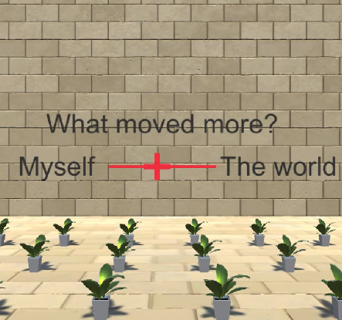

Figure 8: Screenshot from the judgment phase from the self-motion perception task.

**Description:** In this task, we measure to what extent you perceive self-motion – do you perceive that you were moving? Or did the world move while you were still? On each trial, you are moved visually through the environment as (occasionally) in the Main Experiment before. Please keep looking at the red fixation cross while you are being moved. After experiencing each motion, you can use the joystick on either of your controllers to judge on a sliding scale to what extent you felt that you moved (Figure 8). During this part, you can look wherever you want. Confirm your choice by pressing the trigger and the next trial starts. There are no wrong answers here, so please feel free to respond whatever reflects your perception. You can view a short sequence from this experiment [here (Link to data and code repository GitHub)](https://github.com/b-jorges/Motion-Perception-during-Self-Motion/blob/master/Figures/Selfmotion%20judgement.mp4).

## Wrap-up

After finishing the last task, please collect all data files from the folders. You are looking for “.txt” files whose names end on “Stereotest”, “Training”, “MainExperiment” or “Selfmotion”, respectively. Send these files back to us. Once we receive the files and we verify that the informed consent form has been signed, we will dispatch your payment and, depending on your localization and payment, you should receive it within a week. Once the project is done, we will send you a debrief with the results of this study.

## Contact

We are happy to have you contact us and we are happy to try and help with any issues you might be having.

|  |  |
| --- | --- |
| **Björn** | **Rachel** |
| *Email:* b_jorges@yorku.ca | rfan411@gmail.com |
| *Twitter:* @b_jorges |  |